|  |  |  |
| --- | --- | --- |
| **Lab No: 1** | **Android Application that uses GUI components, Font Size** | **Date: 31/08/2020**  **ABHISHEK SRIVASTAVA**  **19BCE10071** |

|  |
| --- |
| **Aim:**  To develop a Simple Android Application that uses GUI components, Font size. |
| **Procedure:**  1. Create a new react-native app using expo (expo init my-list-app)  2. In the Terminal, cd into the project directory using ( cd my-list-app/ )  3. In the Terminal, start the App ( expo start )  5. A Window will open in the browser ( http://localhost:19006/)  6. It will take some time to build and load the project.  7. After completion it will look as shown below:  (This Application include:-  -> App.js  -> Two Components:-  -> Magic.js  -> Boxes.js |

|  |
| --- |
| **Code for App.js**  import React, { useState } from "react";  import { StyleSheet, Text, View, Button } from "react-native";  import Boxes from "./src/Boxes";  import Magic from "./src/Magic";  export default function App() {  const details = {  name: "Abhishek Srivastava",  reg: "19BCE10071",  course: "Mobile App Development",  courseId: "CSE3001",  faculty: "Dr. Satish Kumar L.",  };  const [display, setDisplay] = useState(false);  const displayHandler = () => {  setDisplay(!display);  };  return (  <View style={styles.container}>  <Text style={{ fontSize: 27 }}>Details App</Text>  <View style={{ flex: 1, flexDirection: "row", marginTop: 40 }}>  <View  style={{ width: 250, height: 500, backgroundColor: "powderblue" }}  >  <Boxes />  </View>  <View style={{ width: 250, height: 500, backgroundColor: "skyblue" }}>  {display && <Magic details={details} />}  </View>  </View>  <Button title="Display Details" onPress={displayHandler} />  </View>  );  }  const styles = StyleSheet.create({  container: {  flex: 1,  backgroundColor: "#ffd",  alignItems: "center",  justifyContent: "center",  },  }); |
| **App till Now: -**   |  | | --- | |  |   **Code for Magic.js**  import React, { useState, useEffect } from "react";  import { Text, View } from "react-native";  const Magic = ({ details }) => {  return (  <View  style={{  flex: 1,  flexDirection: "column",  justifyContent: "space-around",  margin: 10,  }}  >  <Text style={{ fontSize: 17 }}>{details.name}</Text>  <Text style={{ fontSize: 17 }}>{details.reg}</Text>  <Text style={{ fontSize: 17 }}>{details.course}</Text>  <Text style={{ fontSize: 17 }}>{details.courseId}</Text>  <Text style={{ fontSize: 17 }}>{details.faculty}</Text>  </View>  );  };  export default Magic; |
| **Final App:** |

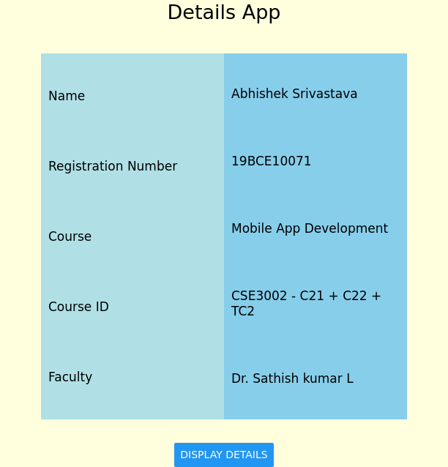

|  |
| --- |
| **Project Files:-** |
| [GitHub Link](https://github.com/abhishek2x/Detail-App)  [Video of Working Project](https://drive.google.com/file/d/11ofho9mvBx-DP64Q0ChDLK7Se44JvRWs/view?usp=sharing) |

|  |
| --- |
| **THANKYOU**  **ABHISHEK SRIVASTAVA**  **19BCE10071** |